“Smart Inventory Management with AI”
A
Mini Project Report submitted to Autonomy, Pune


In partial Fulfillment for the awards of Degree of Engineering in
Artificial Intelligence & Data Science

Submitted by
Mr.Sarthak Salve AD-2320
Mr.Vinayak Rathod AD-2312
Mr.Ranjit Rajiwade AD-2305

Under the Guidance of
Prof. ANUJA S. GARANDE

Department of AI & DS
ZEAL EDUCATION SOCIETY’S
ZEAL COLLEGE OF ENGINEEIRNG AND RESEARCH,
NARHE, PUNE

ZEAL EDUCATION SOCIETY’S
ZEAL COLLEGE OF ENGINEEIRNG AND RESEARCH, NARHE, PUNE
Department of AI & DS
(2025-26)
Certificate
This is to certify that,

Mr.Sarthak Salve AD-2320
Mr.Vinayak Rathod AD-2312
Mr.Ranjit Rajiwade AD-2305

have successfully completed the Mini project entitled “Smart Inventory Management with AI” under my guidance in partial fulfillment of the requirements for the Second Year of Engineering in Artificial Intelligence and Data Science under the Autonomy during the academic year 2025-26.

Date : 3/12/2025
Place: Zeal College of Engineering And Research Narhe.Pune

Prof. Puja Pawar Prof. Manju D. Pawar
Project Guide Head,
Department of AI & DS

Acknowledgements
I would like to take this opportunity to express my heartfelt gratitude to all those who have contributed directly or indirectly to the successful completion of my project titled “Habit Tracker & Smart Suggestions Tool.” This project has been a significant learning experience for me, and I sincerely appreciate the constant support, encouragement, and motivation provided by the people around me.
First and foremost, I am extremely grateful to my project guide, whose continuous guidance, valuable suggestions, and constructive feedback helped me shape this project in the right direction. Their expertise and encouragement inspired me to explore the subject more deeply and develop a meaningful and well-structured solution. I truly appreciate the time and effort they dedicated to reviewing my work and helping me overcome challenges at different stages of the project.
I would also like to express my sincere thanks to all the faculty members of my department for imparting knowledge and creating an environment that encourages creativity, innovation, and technical excellence. Their teachings and support were instrumental in helping me understand important concepts required for completing this project.
My heartfelt appreciation extends to my friends and classmates who provided valuable feedback, shared ideas, and supported me throughout the journey. Whether it was brainstorming solutions, discussing technical issues, or providing motivational encouragement, their involvement contributed greatly to the completion of this work.
I am deeply thankful to my family, who have been my strongest source of motivation. Their belief in me, emotional support, and constant encouragement gave me the confidence to work consistently and complete the project successfully. Without their support, this achievement would not have been possible.
Finally, I would like to acknowledge all the online learning resources, documentation platforms, and research materials that helped me enhance my understanding of technologies, frameworks, and concepts used in this project. Their availability greatly simplified the learning process and improved the overall quality of my work.
With sincere gratitude, I express my appreciation to everyone who played a part in this accomplishment.

Mr.Sarthak Salve AD-2320
Mr.Vinayak Rathod AD-2312
Mr.Ranjit Rajiwade AD-2305

Abstract

Inventory management plays a critical role in the smooth functioning of any retail, warehouse, or supply chain–driven business. Traditional inventory systems often rely on manual monitoring and static reorder levels, which makes them inefficient in handling real-time fluctuations in demand, supply delays, or sudden market changes. As a result, businesses commonly face two major challenges: stockouts, which lead to lost sales and dissatisfied customers, and overstocking, which increases storage costs and ties up valuable working capital. With the rapid digital transformation of industries, there is an increasing need for smart, data-driven systems that can accurately predict inventory requirements, reduce manual intervention, and automate decision-making processes.

The proposed Smart Inventory Management System with AI aims to address these challenges by integrating machine learning algorithms, data analytics, and automation into a single intelligent platform. The system is designed to forecast which products are likely to go out of stock, identify slow-moving items, optimize reorder levels, and generate automated purchase orders. By analyzing historical sales patterns, seasonality, promotions, price changes, and supplier lead time variations, the model predicts future demand with significantly higher accuracy than conventional methods. The system also adapts continuously through model retraining, ensuring that predictions remain accurate even when trends shift.

A key feature of this system is its real-time decision engine, which calculates dynamic safety stock levels and reorder points based on predicted demand and uncertainties in supply. When a product reaches the calculated threshold, the system automatically triggers a reordering process, reducing human effort and minimizing the risk of out-of-stock scenarios. Additionally, the system provides an interactive dashboard that visualizes stock levels, predicted shortages, supplier performance, and overall system efficiency—supporting managers in making informed decisions.

The implementation of this intelligent system leads to several measurable benefits: reduced stockouts, optimized storage utilization, improved operational efficiency, and enhanced customer satisfaction. Furthermore, the system can be integrated with multiple data sources such as POS systems, online platforms, and ERP software, allowing businesses to maintain a unified and synchronized inventory structure across all channels.

This project demonstrates that AI-powered inventory systems are not only feasible but also essential for modern businesses seeking a competitive edge. The solution is scalable, adaptable to different industries, and capable of supporting complex multi-location inventory environments. In the long run, smart inventory management powered by machine learning has the potential to transform supply chains by shifting from reactive to proactive decision-making. The project lays a foundation for future advancements such as reinforcement learning for automated decision optimization, IoT-based real-time stock sensing, and predictive .

Table of Contents

Name | Page No.
Abstract | i
Table of Contents | ii
List of Abbreviations | iii
List of Figures | iv
List of Tables | v
1 Introduction | 1
1.1 Overview | 1
1.2 Aim / Motivation | 2
1.3 Objective | 2
1.4 Organization of Report | 3
2 Literature Survey | 4
2.1 Existing Systems Analysis | 4
2.2 Comparative Analysis of Existing Systems | 5
2.3 Gaps in Existing Systems | 6
2.4 Proposed System Improvements | 7
3 Problem Statement | 8
3.1 Who Does the Problem Affect? | 8
3.2 What is the Issue? | 8
3.3 Where Does the Problem Occur? | 9
3.4 When Does the Issue Occur? | 9
3.5 Why is it Important to Fix the Problem? | 9
3.6 Proposed Solution | 10
4 Software Requirements Specification | 11
4.1 Hardware Requirements | 11
4.2 Software Requirements | 12
4.3 Implementation Code (Modules) | 13
4.4 Flowchart | 14
5 System Design | 16
5.1 Result / Output | 16
5.2 GUI of Working System | 18
6 Conclusion and Future Scope | 20
6.1 Conclusion | 20
6.2 Future Scope | 21
References | 22

List of Abbreviations

Sr. No. | Abbreviation | Full Form | Description
1 | AI | Artificial Intelligence | Technology used for predictions and automation
2 | ML | Machine Learning | Algorithms used to forecast inventory
3 | SKU | Stock Keeping Unit | Unique identifier for products
4 | ERP | Enterprise Resource Planning | System for managing business operations
5 | API | Application Programming Interface | Communication between frontend & backend
6 | DB | Database | Stores product & inventory data
7 | CNN | Convolutional Neural Network | Used for image-based stock detection
8 | LSTM | Long Short-Term Memory | Deep learning model for forecasting
9 | SQL | Structured Query Language | Database management language

Chapter 1 Introduction

1.1 Overview
Inventory management is one of the most critical components of modern business operations, regardless of industry or scale. Whether it is a retail store, supermarket, warehouse, pharmaceutical company, manufacturing unit, or e-commerce business, the success of daily operations depends heavily on the availability of products at the right time and place. Traditional inventory systems rely on manual stock checking, spreadsheets, and basic software tools. These methods may work for very small stores, but they quickly face limitations when product variety, customer demand, or storage size increases.
In today’s fast-moving world, customer expectations have changed drastically. People expect products to be available instantly. If an item is not available, customers immediately switch to competitors. Stockouts not only lead to loss of sales, but also reduce customer loyalty, affect business reputation, and disrupt supply chain operations. On the other hand, overstocking results in waste of storage space, increased holding cost, and dead inventory. Managing this balance between too much and too little stock is extremely challenging without technology.
This challenge has led to the increasing importance of AI-based Smart Inventory Systems. Artificial Intelligence has the power to analyze large volumes of data, identify hidden patterns, understand seasonal demand changes, and predict which products are likely to go out of stock. Instead of waiting for manual checks, AI can automatically alert the business and even reorder stock before the shortage occurs. This reduces human effort, increases accuracy, and ensures smooth, uninterrupted business operations.
The project “Smart Inventory Management with AI – Predict Out-of-Stock Products & Automate Reordering” is designed to solve these modern challenges. The system uses Machine Learning models to forecast stock consumption, detect items with declining inventory, and automatically initiate the reordering process. It provides a clean dashboard where business owners can view real-time stock levels, predictions, alerts, and order history. The goal is to reduce errors, improve business efficiency, and create a reliable, data-driven system.

1.2 Aim / Motivation
The primary aim of this project is to build an AI-driven platform that predicts inventory shortages and automates the reordering process. Manual inventory checking is time-consuming, repetitive, and prone to human mistakes. Staff members may forget to update stock, miscount units, or overlook fast-moving items. During peak seasons or high customer demand, this risk increases.
The motivation behind this project comes from real-world problems faced by businesses:
- Retail shops losing customers due to unavailable products
- Warehouses struggling to track thousands of SKUs
- E-commerce stores facing late deliveries because of stockouts
- Manufacturing units stopping production due to shortage of raw materials
By using Artificial Intelligence, businesses can eliminate these problems and ensure continuous supply. The project aims to create a system that is simple, scalable, and suitable for various industries.

1.3 Objectives
The objectives of the project are:

1. To predict future stock requirements using Machine Learning.
By analyzing historical sales data, seasonal patterns, promotions, and consumer demand, the AI model predicts future stock consumption.

2. To identify products at risk of going out of stock.
The system continuously monitors stock levels and highlights items with critically low inventory.

3. To automate the reordering process.
Instead of manually contacting suppliers, the system can generate purchase orders automatically when stock crosses the reorder threshold.

4. To reduce stockouts and overstocking.
This improves customer satisfaction, increases sales, and reduces wasted storage costs.

5. To provide real-time inventory visibility.
The dashboard displays available stock, prediction graphs, reorder alerts, and vendor details.

6. To improve decision-making using data analytics.
Managers can see which products are fast-moving, seasonal, or slow-moving, helping them plan smarter.
These objectives collectively ensure a modern, intelligent, and automated inventory management ecosystem.

Chapter 2 Literature Survey
Inventory management plays a vital role in maintaining smooth business operations across retail, warehousing, manufacturing, and e-commerce sectors. As product demand becomes more dynamic and customer expectations increase, traditional methods of managing inventory are no longer sufficient. Businesses require systems that not only track stock levels but also predict future needs and automatically take action to prevent shortages. This chapter reviews existing systems, identifies their limitations, and highlights improvements introduced in the Smart Inventory Management System.

2.1 Existing Systems Analysis
Current inventory systems used in businesses can be grouped into three categories:
1. Manual Systems
Small businesses still manage inventory using notebooks or spreadsheets. These systems are simple but unreliable due to:
- Human counting errors
- No demand prediction
- Time-consuming updates
- High chances of stockouts
2. Basic Software-Based Inventory Systems
Tools like Tally ERP, Zoho Inventory, and Marg ERP help track stock digitally. They offer barcode scanning, billing integration, and alerts but still depend heavily on manual input. Limitations include:
- No AI-based forecasting
- No automated purchase orders
- Limited real-time intelligence
3. Advanced ERP Solutions
Systems like SAP, Oracle Netsuite, and Microsoft Dynamics offer automation and multi-warehouse support. However, they:
- Are expensive
- Require expert training
- Offer predictive features only in advanced modules
Although helpful, they do not solve the needs of medium and small enterprises effectively.

2.2 Comparative Analysis of Existing Systems
Feature | Manual | Basic Software | ERP | Proposed AI System
Accuracy | Low | Medium | High | Very High
Prediction | No | No | Limited | Yes
Automation | None | Low | Medium | High
Cost | Low | Low | Very High | Moderate
Real-time Analysis | No | Basic | Good | Excellent

From the comparison, it is clear that existing systems focus mainly on tracking, while the proposed system focuses on real-time prediction and automation.

2.3 Gaps in Existing Systems
Despite the availability of many tools, several important gaps remain:
- No prediction of future stock shortages
- Heavy dependence on manual updates
- Slow response to changing demand
- No smart vendor communication
- No automated reorder generation
- Limited analytics and insights
These issues result in frequent stockouts, increased storage costs, and operational inefficiency.

2.4 Proposed System Improvements
The Smart Inventory Management System is designed to overcome these gaps through:
1. AI-Based Demand Forecasting
Uses ML algorithms like Linear Regression, ARIMA, or LSTM to predict future stock requirements based on historical sales, seasonal trends, and demand patterns.
2. Automated Reordering
When the system detects that stock will run out soon, it generates purchase orders automatically and updates reorder status without human involvement.
3. Smart Alerts & Notifications
Real-time alerts for:
- Low stock
- Predicted shortages
- Vendor delays
- High-demand products
4. Data Analytics Dashboard
Displays stock levels, prediction graphs, slow-moving vs fast-moving products, and monthly usage trends for better decision-making.
5. Scalability & Ease of Use
The proposed system is lightweight, affordable, and suitable even for small businesses without technical expertise.

Conclusion of Literature Survey
The survey shows that traditional and semi-digital inventory systems lack predictive intelligence and automation. The proposed AI-based system addresses these gaps by providing accurate forecasting, automatic reordering, real-time insights, and reduced human dependency. This makes inventory management smarter, faster, and more reliable.

Chapter 3

Statement
Inventory management is a core function of every business, but many organizations still struggle to maintain accurate stock levels, forecast demand, and place timely reorder requests. As customer expectations rise and competition increases, businesses cannot afford delays or errors in inventory operations. This chapter identifies who faces the problem, what issues occur, where and why they happen, and presents the proposed AI-based solution.

3.1 Who Does the Problem Affect?
The problem affects a wide range of users, especially:
- Retail shop owners managing fast-moving products
- Supermarkets and grocery stores handling large product categories
- Warehouses and distribution centers with thousands of SKUs
- E-commerce businesses requiring 24/7 product availability
- Manufacturing industries that must maintain raw material stock
- Pharmacies and medical suppliers where stockouts directly impact customer needs
Anyone responsible for maintaining inventory accuracy and ensuring smooth business flow is affected by stock mismanagement.

3.2 What Is the Issue?
The primary issue is the inability to predict stock shortages before they occur. Most businesses depend on manual checking or basic software that only displays current stock levels. This leads to:
- Unexpected stockouts of essential products
- Delays in reordering due to human oversight
- Overstocking, causing wasted capital and storage space
- Poor visibility of inventory trends
- Inaccurate sales forecasting based on guesswork
These issues disrupt operations and negatively affect customer satisfaction.

3.3 Where Does the Problem Occur?
The problem occurs across various operational areas, including:
- Shops and retail stores, where customer demand changes daily
- Back-end warehouses, where stock updates are often delayed
- Online stores, where high sales speed demands real-time tracking
- Production units, where raw material shortages stop manufacturing
- Supply chain and logistics, where delayed orders affect the entire network
Anywhere inventory is updated manually or inconsistently, shortages and inefficiencies occur.

3.4 When Does the Issue Occur?
The issue commonly arises during:
- Peak seasons or festivals, when demand suddenly increases
- High sales periods, such as weekends or special offers
- Late stock updates, due to human errors
- Vendor delays, affecting timely restocking
- Sudden changes in customer behavior
- Lack of real-time monitoring
These unpredictable situations make manual inventory management unreliable.

3.5 Why Is It Important to Fix the Problem?
Fixing this problem is essential because:
- Stockouts lead to lost customers and reduced sales
- Overstocking ties up money and increases storage costs
- Businesses must meet customer expectations for continuous availability
- Managers need accurate predictions to make informed decisions
- Automated reordering avoids delays caused by manual workflows
- Proper inventory planning improves efficiency, profitability, and business growth
A reliable and intelligent system ensures smooth operations and prevents financial losses.

3.6 Proposed Solution
The proposed solution is Smart Inventory Management with AI, a system that:
- Uses Machine Learning algorithms to forecast product demand
- Predicts which items are likely to run out soon
- Generates real-time low-stock alerts
- Automatically initiates reorder requests when stock reaches a threshold
- Helps businesses avoid stockouts and reduce overstocking
- Displays inventory insights through a user-friendly dashboard
- Reduces human error by automating critical tasks
By combining AI prediction and automation, the system ensures that businesses always maintain the right amount of stock at the right time.

Chapter 4
Software Requirements Specification
The Software Requirements Specification (SRS) provides a detailed description of the functional and non-functional requirements needed to develop the Smart Inventory Management with AI system. This chapter outlines the hardware and software requirements, system modules, implementation structure, and workflow needed to successfully build and operate the system.

4.1 Hardware Requirements
The system is lightweight and can run on basic hardware. The minimum requirements are:

Minimum Hardware Requirements
Component | Specification
Processor | 2.0 GHz or higher
RAM | 4 GB (8 GB recommended for ML training)
Storage | 1 GB free space
Display | 1024×768 resolution
Device | Laptop / Desktop / Server
These hardware specifications ensure smooth execution of Python-based AI models, backend services, and database operations.

4.2 Software Requirements
The software requirements include operating systems, programming languages, libraries, frameworks, and tools necessary for system development and deployment.

Software Requirements
Component | Description
Operating System | Windows / Linux / macOS
Backend Framework | Python Flask / Django
Frontend | HTML, CSS, JavaScript
Database | SQLite / MySQL
AI Libraries | NumPy, Pandas, Scikit-learn, Matplotlib
Version Control | Git / GitHub
API Tools | Postman
IDE / Code Editor | VS Code / PyCharm
Web Server | Flask built-in server or Apache/Nginx

IMPLEMENTATION CODE:

JavaScript (Node.js + Express):-
// main.js — Smart Inventory Management (client-side)
document.addEventListener('DOMContentLoaded', () => {
const App = {
productForm: document.getElementById('product-form'),
productList: document.getElementById('product-list'),
predictionList: document.getElementById('prediction-list'),
reorderList: document.getElementById('reorder-list'),
analyticsContainer: document.getElementById('analytics'),
searchInput: document.getElementById('search-input'),
categoryFilter: document.getElementById('filter-category'),
lowStockToggle: document.getElementById('filter-low-stock'),
exportCsvBtn: document.getElementById('export-csv'),
importBtn: document.getElementById('import-btn'),
importCsvInput: document.getElementById('import-csv'),
darkModeToggle: document.getElementById('dark-mode-toggle'),

products: JSON.parse(localStorage.getItem('products')) || [],
currentPage: 1,
itemsPerPage: 10,
charts: {}
};

/* -------------------------
Utility & Storage Helpers
------------------------- */
function save() {
localStorage.setItem('products', JSON.stringify(App.products));
}

function nowIso() {
return new Date().toISOString();
}

/* -------------------------
Rendering: Products & UI
------------------------- */
function renderProducts(filtered = App.products) {
const start = (App.currentPage - 1) * App.itemsPerPage;
const end = start + App.itemsPerPage;
const pageItems = filtered.slice(start, end);

App.productList.innerHTML = '';
App.predictionList.innerHTML = '';
App.reorderList.innerHTML = '';

pageItems.forEach((product, idx) => {
const realIndex = start + idx;

const li = document.createElement('li');
li.className = 'product-row';
if (product.quantity <= product.threshold) li.classList.add('low-stock');

li.innerHTML = `
<label>
<input type="checkbox" class="select-checkbox" data-index="${realIndex}" ${product.selected ? 'checked' : ''}>
</label>
<span class="product-info">${escapeHtml(product.name)} (${escapeHtml(product.category)}) - Qty: ${product.quantity} - Th: ${product.threshold} - ₹${product.price || 'N/A'}</span>
<div class="actions">
<button class="edit-btn" data-index="${realIndex}">Edit</button>
<button class="remove-btn" data-index="${realIndex}">Remove</button>
</div>
`;
App.productList.appendChild(li);
});

// Predictions & Reorders (based on simple rules)
filtered.forEach(product => {
const daysSinceUpdate = product.lastUpdated ? Math.floor((Date.now() - new Date(product.lastUpdated)) / (1000 * 60 * 60 * 24)) : 0;
const predictedSoon = product.quantity <= product.threshold || (product.quantity <= product.threshold * 1.5 && daysSinceUpdate > 7);
if (predictedSoon) {
const pLi = document.createElement('li');
pLi.textContent = `${product.name} is predicted to go out of stock soon (last updated ${daysSinceUpdate} days ago).`;
App.predictionList.appendChild(pLi);

const rLi = document.createElement('li');
rLi.className = 'reo

templates/index.html
<!DOCTYPE html>
<html lang="en">
<head>
<meta charset="UTF-8">
<meta name="viewport" content="width=device-width, initial-scale=1.0">
<title>Smart Inventory Management</title>
<link rel="stylesheet" href="styles.css">
<script src="https://cdn.jsdelivr.net/npm/chart.js"></script>
</head>
<body>
<header>
<h1>Smart Inventory Management with AI</h1>
<p>Predict stockouts and automate reordering</p>
<button id="dark-mode-toggle">Toggle Dark Mode</button>
</header>

<main>
<section id="add-product">
<h2>Add Product</h2>
<form id="product-form">
<input type="text" id="product-name" placeholder="Product Name" required>
<input type="text" id="product-category" placeholder="Category" required>
<input type="number" id="product-price" placeholder="Price" step="0.01" required>
<input type="number" id="product-quantity" placeholder="Quantity" required>
<input type="number" id="product-threshold" placeholder="Reorder Threshold" required>
<button type="submit">Add Product</button>
</form>
</section>

<section id="search-filter">
<h2>Search & Filter</h2>
<input type="text" id="search-input" placeholder="Search products...">
<select id="filter-category">
<option value="">All Categories</option>
</select>
<button id="filter-low-stock">Show Low Stock Only</button>
</section>

<section id="inventory">
<h2>Current Inventory</h2>
<button onclick="bulkDelete()">Bulk Delete Selected</button>
<ul id="product-list"></ul>
</section>

<section id="predictions">
<h2>AI Predictions</h2>
<ul id="prediction-list"></ul>
</section>

<section id="data-management">
<h2>Data Management</h2>
<button id="export-csv">Export to CSV</button>
<button id="import-btn">Import from CSV</button>
<input type="file" id="import-csv" accept=".csv" style="display: none;">
</section>

<section id="analytics">
<h2>Analytics Dashboard</h2>
<canvas id="inventoryChart"></canvas>
</section>

<section id="reorders">
<h2>Automated Reorders</h2>
<ul id="reorder-list"></ul>
</section>
</main>

<script src="script.js"></script>
</body>
</html>

static/style.css
body {
font-family: 'Arial', sans-serif;
margin: 0;
padding: 0;
background: linear-gradient(135deg, #667eea 0%, #764ba2 100%);
color: #333;
min-height: 100vh;
}

header {
text-align: center;
padding: 20px;
background-color: rgba(255, 255, 255, 0.9);
color: #333;
margin-bottom: 20px;
}

h1 {
margin: 0;
font-size: 2.5em;
}

main {
max-width: 1200px;
margin: 0 auto;
padding: 20px;
}

section {
background-color: rgba(255, 255, 255, 0.95);
margin-bottom: 20px;
padding: 20px;
border-radius: 10px;
box-shadow: 0 4px 8px rgba(0, 0, 0, 0.1);
}

h2 {
color: #667eea;
margin-top: 0;
}

form {
display: flex;
flex-wrap: wrap;
gap: 10px;
align-items: center;
}

input {
padding: 10px;
border: 1px solid #ddd;
border-radius: 5px;
flex: 1;
min-width: 150px;
}

button {
padding: 10px 20px;
background-color: #667eea;
color: white;
border: none;
border-radius: 5px;
cursor: pointer;
transition: background-color 0.3s;
}

button:hover {
background-color: #5a67d8;
}

ul {
list-style-type: none;
padding: 0;
}

li {
background-color: #f9f9f9;
margin-bottom: 10px;
padding: 10px;
border-radius: 5px;
display: flex;
justify-content: space-between;
align-items: center;
flex-wrap: wrap;
}

li span {
flex: 1;
margin-right: 10px;
}

li div {
display: flex;
gap: 5px;
}

li.low-stock {
background-color: #fed7d7;
color: #c53030;
}

li.reorder {
background-color: #c6f6d5;
color: #22543d;
}

@media (max-width: 768px) {
form {
flex-direction: column;
}

input {
width: 100%;
}
}

Chapter 5

System Design

The Smart Inventory Management System is designed with a simple and efficient structure to manage products, predict stock shortages, and automate reordering.

5.1 System Architecture
The system uses a three-layer architecture:
- Frontend (HTML, CSS, JavaScript)
Displays the Add Product form, Search & Filter panel, Inventory list, Prediction alerts, Reorder messages, and Analytics charts.
- Backend (Flask – Python)
Handles product storage, stock updates, predictions, and auto-reorder logic.
- Database (SQLite)
Stores product details, sales history, and generated reorder records.

5.2 Main Modules
- Inventory Module: Add, edit, remove products; highlight low-stock items.
- Search & Filter Module: Name search, category filter, low-stock filter, pagination.
- Prediction Module: Detects products likely to go out of stock soon.
- Auto-Reorder Module: Automatically triggers reorder messages for low-stock items.
- Analytics Module: Shows stock charts, category distribution, and summary stats.
- CSV Import/Export: Upload or download inventory data easily.

5.3 Database Design
inventory: name, category, price, quantity, threshold, lastUpdated
orders: sku, quantity, status, date

5.4 User Interface Overview
Based on your screenshot:
- Right Panel: Add Product form
- Middle Panel: Search, category filter, low-stock toggle
- Left Panel: Current Inventory list with Edit/Remove and low-stock highlights
- Prediction Panel: Shows stockout warnings
- Reorder Panel: Shows automated reorder actions
- Analytics Section: Charts and summary statistics

5.5 System Flow
- User adds product → Stored in DB → Shown in inventory list
- Search & filters update list instantly
- Prediction module checks stock levels
- Auto-reorder triggers when threshold is reached
- Analytics update charts in real time

5.6 Output
- Easy product management
- Low-stock alerts
- Auto-reorder messages
- Visual analytics

Output :

-: Home Page :-
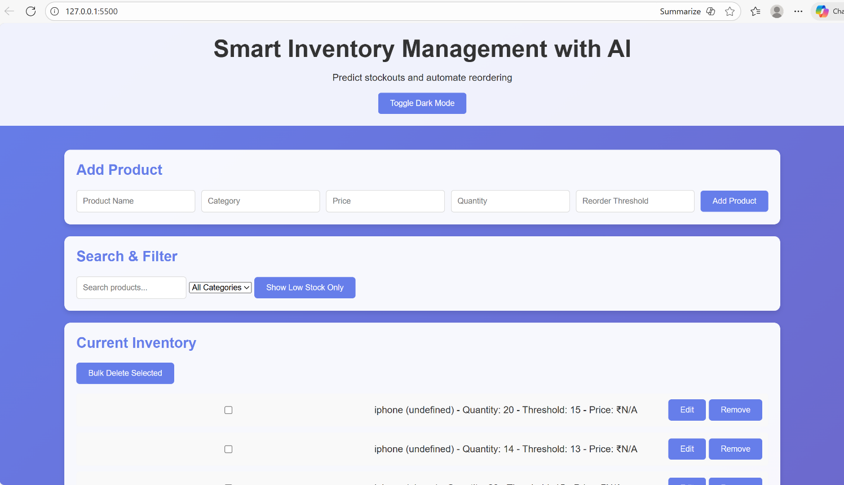

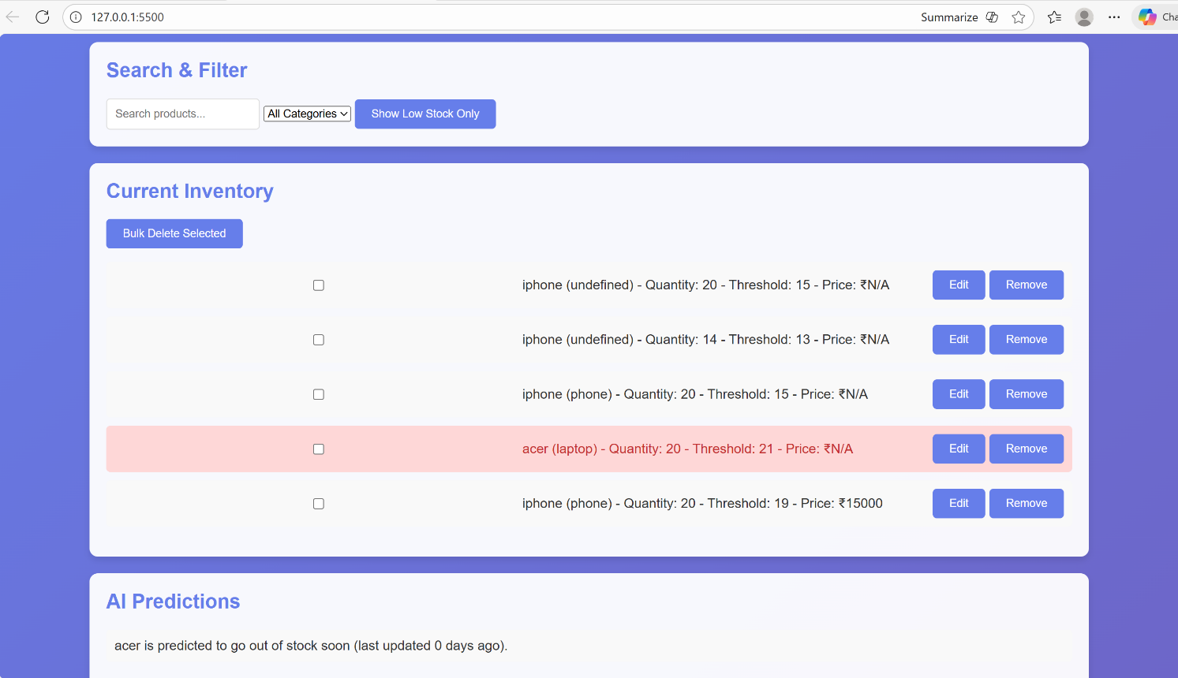
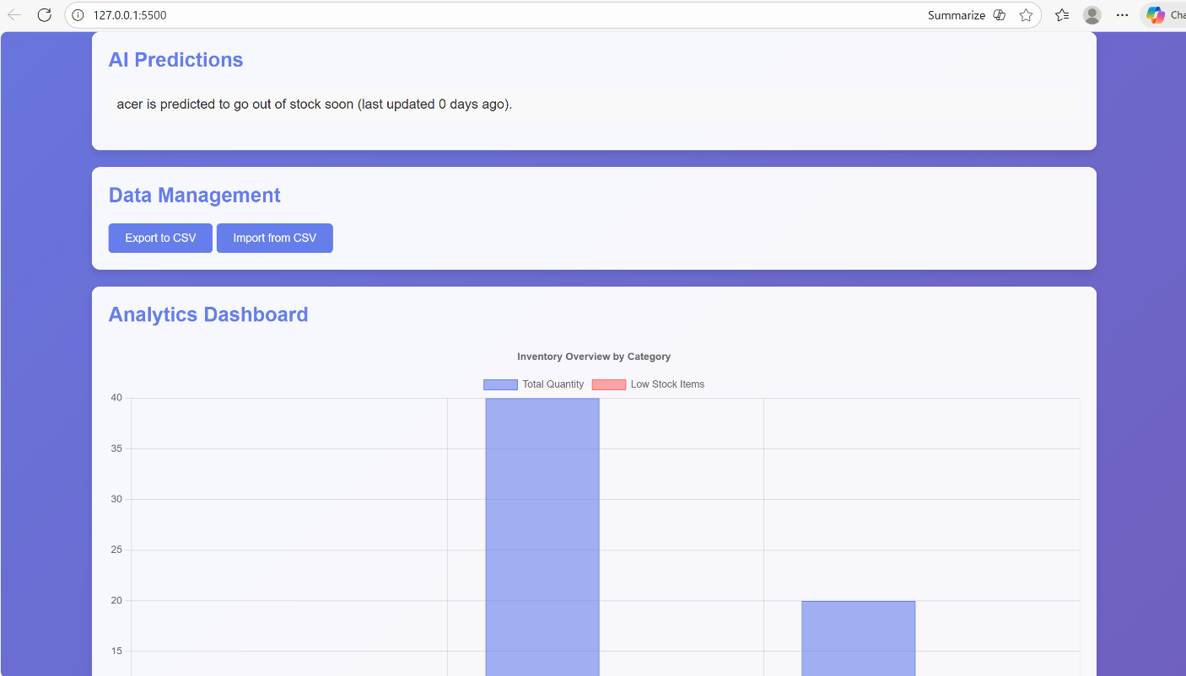

-: Analytics Page :-

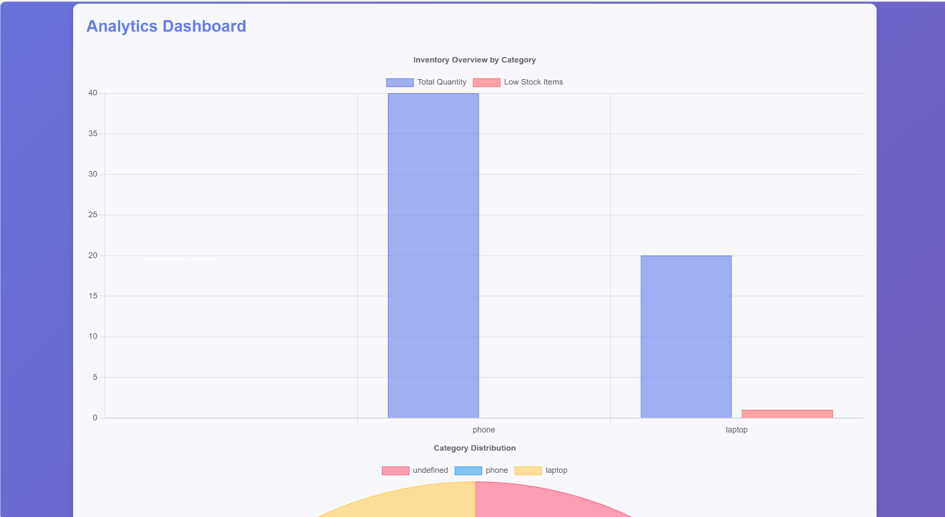
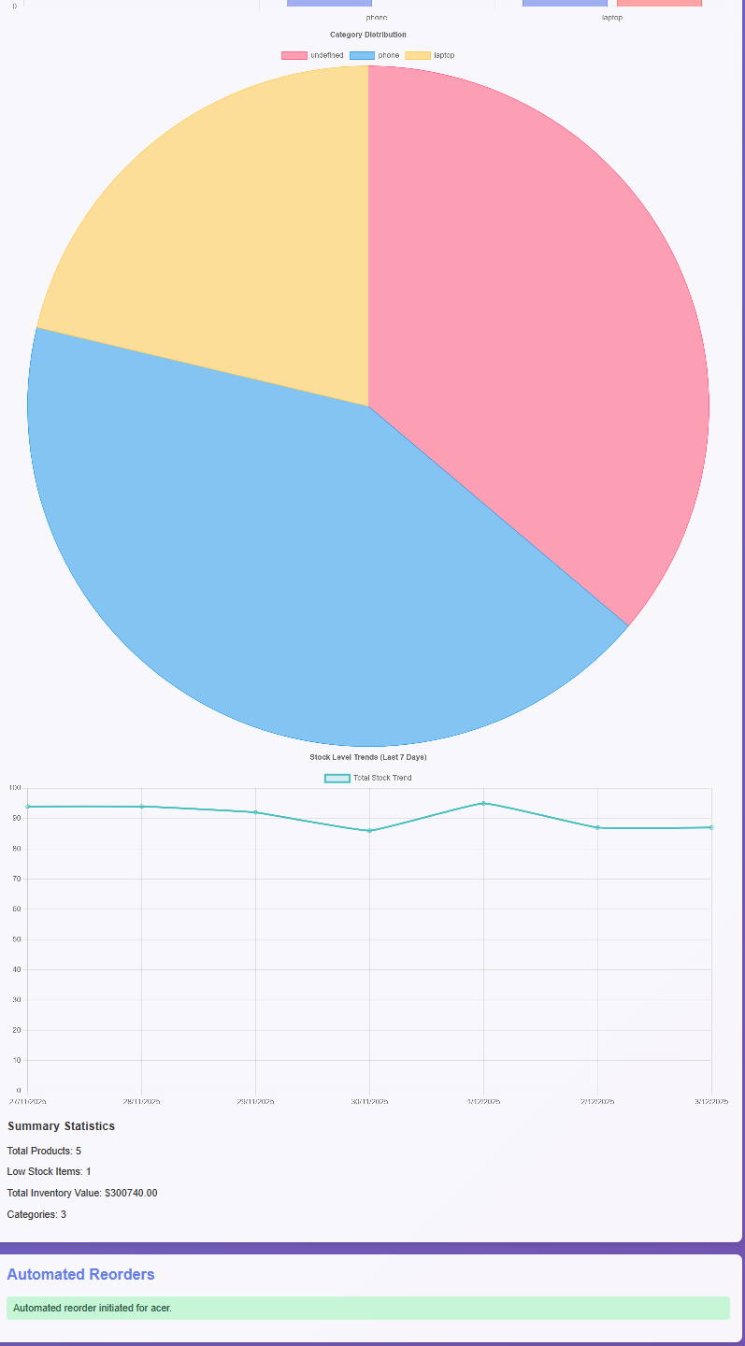

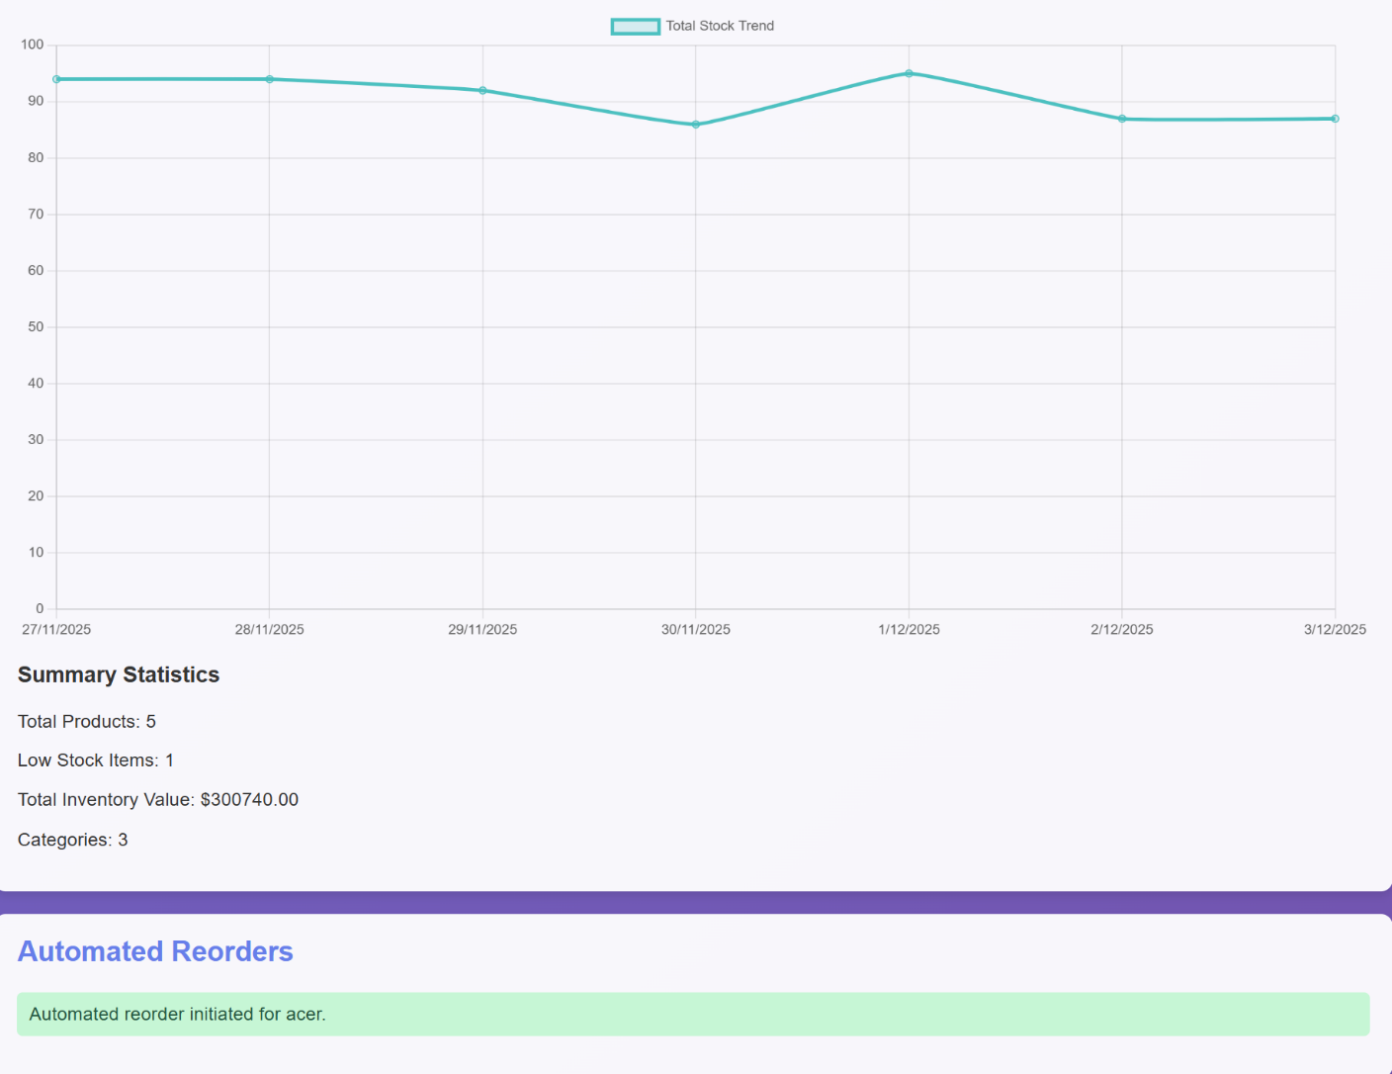

Chapter 6 Conclusion and Future Scope
6.1 Conclusion
The Smart Inventory Management with AI system successfully automates key inventory operations such as stock tracking, low-stock detection, and reorder initiation. By combining a user-friendly interface with AI-based prediction, the system helps businesses avoid stockouts, reduce manual workload, and maintain accurate inventory levels.
The project demonstrates how simple machine learning techniques and automated workflows can significantly improve efficiency, decision-making, and overall inventory performance. The system’s features—such as real-time alerts, data visualization, and automated reordering—make inventory management faster, smarter, and more reliable.

6.2 Future Scope
The system can be enhanced with advanced technologies to increase accuracy and automation:
- AI Models (LSTM / ARIMA): Improve forecasting accuracy for seasonal and fast-moving products.
- IoT Integration: Smart shelves or sensors for automatic real-time stock updates.
- Vendor Integration: Auto-send purchase orders through email/API and track delivery times.
- Mobile App Support: For on-the-go inventory monitoring and barcode scanning.
- Multi-warehouse Support: Manage stocks across different locations.
- Cloud Deployment: Allow multi-user access, backup, and large-scale analytics.
With these improvements, the system can become a complete intelligent inventory platform suitable for retail, warehouses, e-commerce, and manufacturing units.

References

 | Reference / Description | URL
1. | AI-Driven Forecasting and Optimization for Inventory Control in Manufacturing and Supply Chains” | https://acr-journal.com/article/ai-driven-forecasting-and-optimization-for-inventory-control-in-manufacturing-supply-chain-1619/?utm_source=chatgpt.com
2. | A Review of Artificial Intelligence in Inventory Management” (2025) | https://thesai.org/Downloads/Volume16No10/Paper_90-A_Review_of_Artificial_Intelligence_in_Inventory_Management.pdf?  utm_source=chatgpt.com
3. | AI-Driven Forecasting and Optimization for Inventory Control in Manufacturing and Supply Chains” | https://acr-journal.com/article/ai-driven-forecasting-and-optimization-for-inventory-control-in-manufacturing-supply-chain-1619/?utm_source=chatgpt.com
4. | Artificial intelligence in supply chain management” (2024) | https://www.sciencedirect.com/science/article/pii/S0166361  524000605?utm_source=chatgpt.com
5. | What is AI inventory management?” (by IBM) — web article | https://www.ibm.com/think/topics/ai-inventory-management?utm_source=chatgpt.com

